**Phoenix Care & Education**

**Common Farm**

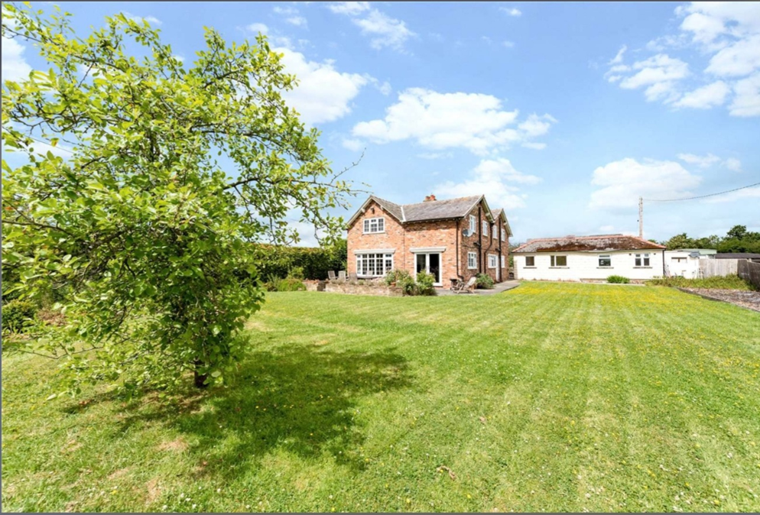

Common Farm, Welsh Road, Balderton, Chester, CH4 9LF

**Young Persons Handbook**

**Common Farm**

**Management Team**

**Nicola**

**Responsible Individual**

**Danielle**

**Home Manager**

**Laura**

**Deputy Manager**

**Common Farm Team Leaders**

**Michelle**

**Samantha**

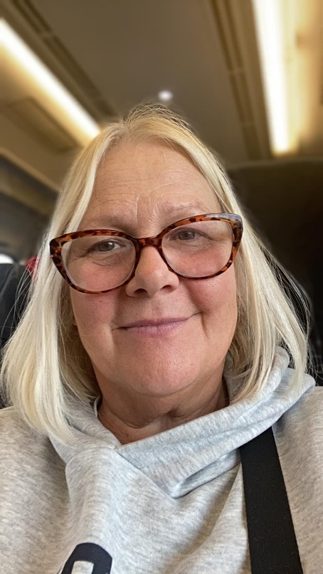

**Tracey**

**Common Farm Residential Support Workers**



**Alex Kelly Haf Hayley Grant**

**Common Farm Regular Visitors**



Paul - Director



Jake – Maintenance/training

Andrea – Reg 44

**Welcome to Common Farm**

Here at Common Farm we want you to feel safe and happy and have lots of fun along the way.

There may be 3 other children that live with you at Common Farm.

Your input is important to us so we have a weekly meeting to talk about upcoming plans for the week ahead including food and activities. We also have a takeaway on a Friday to reward positive behaviour.

Everyone living at Common Farm will have a keyworker who has a responsibility to help share your views and wishes and help you personalise your bedroom.

You will have a set money allowance every week for activities, pocket money, clothing and an opportunity to earn extra reward money by completing agreed targets too.

We will ensure you attend any health appointments and we have a house diary to keep track of these.

We want to ensure you have consistency so we have house cars that we can use to take you to school or to activities in.

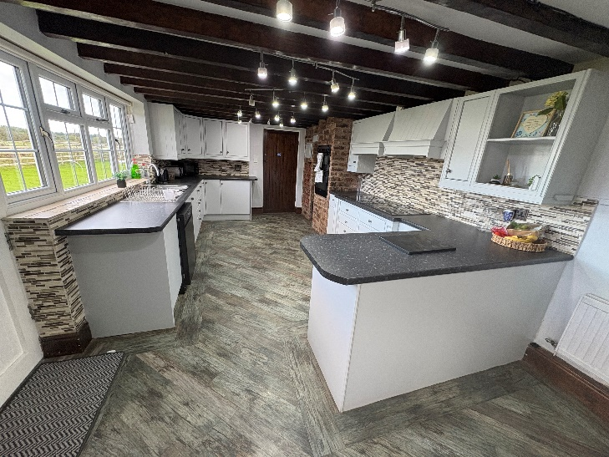

**Things to do in and around Common Farm**





**Chester**

**Movie nights**

**FlipOut**

**Bowling**

**Cinema**

**Arcade**

**Machine**

**Common Farm House Rules**

Wifi is available throughout the day but it does get turned off at 10pm on a school night.

You have a responsibility to keep your room tidy, there may be times that staff have to complete a room search.

Alcohol, cigarettes, vapes and drugs are not allowed in or around the home.

Do not hurt yourself or others.

Do not break things in or around the house.

Bullying and fighting is not acceptable.

Friends must be invited once arranged with staff.

If you are unhappy or worried about something please let staff know.

Bedroom doors and main house doors have alarms on, this is to make sure we know where you are and your are safe.

It is important we use appropriate language, no swearing and using good manners.

Not everyone has access to free time, this is something that must be agreed by managers and social workers.

**Your Rights**

**Having Your Say**

It is important to us all at Common Farm that your voice is listened to.

We often have meetings about people living at Common Farm and you will be asked

if you would like to attend your meetings, if you do not wish to attend we will ask

for your input prior. Your Keyworker can also help you with this.

**How to Complain**

If you feel you need to or want to make a complaint you can:

* Talk to the staff team
* Speak to the manager or deputy manager
* Contact your Social Worker or Independent reviewing officer
* Request to speak to an advocate
* Speak to the Ofsted inspector or Reg 44 visitor
* Call Childline on 0800 1111