

**YOUNG PERSON’S HANDBOOK**

**This book belongs to:**

**My Social Worker is:**

**My Staff Team are:**

**Registered Manager - Veronica Dodd**

**Deputy Manager- Laura Hill**

**Team Leader – Tina Dodd**

**Team Leader – Shaun Gibbons**

**Team Leader –**

**Residential Support Worker – Mick Smith**

**Residential Support Worker – Maria Mortimer**

**Residential Support Worker – Samie Richards**

**Residential Support Worker – Andrea Clifton**

**Residential Support Worker –**

**Barn telephone number is**: **0151 458 4122**

**Your Independent Reviewing Officer is:**

**Telephone Contact Number:**

**Where is**

**New Hall Barn**

New Hall Barn is situated close to Chester City centre. There is plenty to do in the surrounding area, just ask your staff team.

Our address is

New Hall Barn

Kinseys Lane, Ince, Chester, Cheshire West and Chester, CH2 4NS

**How do I get to live at**

**New Hall**

**Barn**

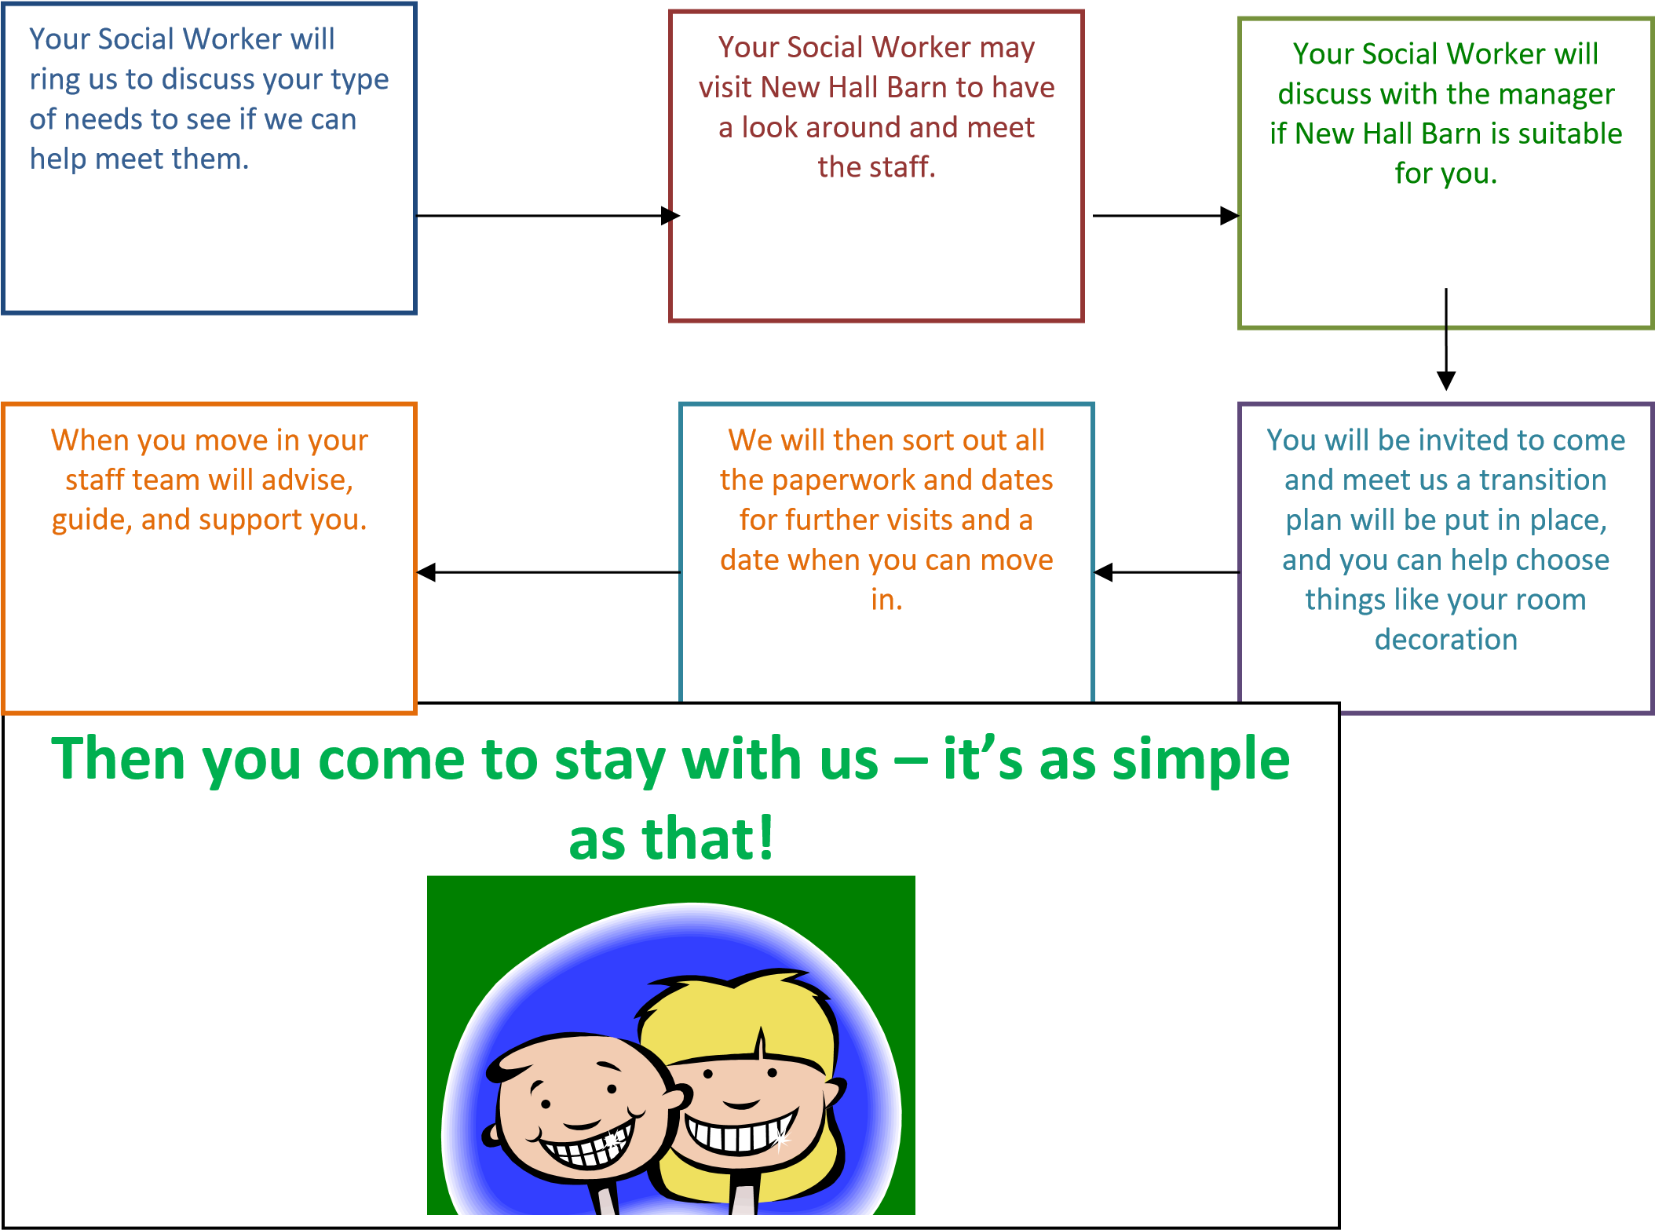

**Who will be looking after me?**

All your staff team have got lots of experience working with young people like you, we know how to help and care for you, and you can talk to us about any problems you might have. We also know how to have lots of fun, and we will make sure you get to do things you enjoy.



**What are Key Workers?**

Each Young Person at New Hall Barn has their own Key Worker.

They will ensure that your needs are met both inside and outside New Hall

Barn.

They will support you with homework, schoolwork, any problems you have, and make time available to have a good chat and help you with education, your money and generally how to care of yourself so you can grow to become independent.

Most importantly, they will get to know you, your family (where possible) and you’re Social Worker. They will be there for you when you need them.

**Young Persons Files**

On the day you arrive at New Hall Barn one of your staff team will set up a

Young Persons File with you that contain information about you, your family, and your needs. This will contain plans for your care called your

PLACEMENT PLAN and this is altered when changes in your care are made.

This file contains all sorts of useful information about you, such as import addresses and telephone numbers of your family and Social Worker. It also contains information on how you are progressing at New Hall Barn.

You can look through this file with any one in your staff team if you want to. It is kept securely locked in the Staff Office at New Hall Barn, so don’t worry if you are living with any other young people, they can’t see it. Feel free to chat to any one in your staff team about what has been written; after all it is about you!

YOUNG PERSONS HOUSE MEETINGS.

Every week, time will be made especially for you to talk to your staff team and tell them about what you think is good and bad about your care plan. This doesn’t mean that if you have any worries or problems you must wait for your Young Persons meeting. You can talk to your staff team about anything at most times.

Questions you might have

Q. How much pocket money do I get?

A. This is your weekly allowance

|  |  |  |  |  |  |
| --- | --- | --- | --- | --- | --- |
| **POCKET MONEY** | **CLOTHING ALLOWANCE** | **Toiletries** | **Activity**  **Money** | **BIRTHDAY**  **GIFTS** | **CHRISTMAS**  **GIFTS** |
| £10 | £15 | £5 | £30 | £100 | £300 |

Activity allowance and clothing are allocated monthly.

Can I smoke?

We would really prefer it if you did not smoke at all because it is bad for your health. If you are a ‘smoker’ when you arrive and you can’t give up, we will talk to your Parents/Social Worker about how best we can help. It is illegal to purchase or attempt to purchase cigarettes if you are under 18.

YOU CANNOT SMOKE ANYWHERE IN THE HOUSE OR ON THE PREMISES

Will I have my own room?

Yes, which you can help choose decoration for your bedroom and an allowance will be given to you to personalise your room to your liking.

On arrival each young person will be given a welcome pack which will include items such as:

* Hygiene products
* Deodorant & Sanitary products if required.
* Toothbrush
* Slippers
* House coat & PJs

Am I allowed to drink alcohol?

No, it is against the law to buy alcohol for any one less than 18 years of age.

What happens at weekends?

We like to go out at weekends or after school to have some fun. Tell us what you would like to do, and we can try to arrange it, providing it doesn’t cost the earth!

If you would like to go out on trips in the school holiday or weekends, just let us know and we will see what we can do!

# WHAT CAN I DO AFTER MY SCHOOL DAY IS OVER

You have the choice to engage with a wide range of local activities or arrange an activity with staff.

You can go walking with staff in the local area. Staff love to go on power walks to help keep you (and them) fit and healthy.

There is leisure centre nearby; and your staff team will find out other activities you might want to participate in when you tell them what you like.



Can I have visitors?

Yes, but you must let us know when you visitors want to come so we can make sure that you are in and that you enjoy your visit with them. Your Social Worker must agree to these visits.

What time do I have to go to bed?

Bedtime varies according to your age. We will chat with you, your Parents or Social Worker to ask what time you usually go to bed.

Bedtimes are usually agreed on your arrival to the home.

These times may be increased at weekends.

Whilst in your bedroom it is ok for you to watch television, read, listen to a CD or radio when you first go to bed to help you settle but only for a short time so you can have a good night’s sleep, it is important you show respect to others sleeping in New Hall Barn.

How often do I have Planned Meetings?

Within 72 hours you will have an initial Placement Planning meeting Four weeks after you first arrive at New Hall Barn an Initial Planning Meeting will take place which involves your social worker, your school, your parents, your staff team, and they look at what plans are in place for your care for the next three months. Don’t worry if you are not at this meeting, you can tell or write down what you want and one of your staff team will speak up for you at the meeting. After the meeting they will sit down with you and tell you what was said and what was decided.

After this you will have a Planning Meeting every 3 months which we hope you will attend. A full Review is held every 6 months.

What do I call the staff?

Just call us by our first names - don’t worry we’ve got photos, so you know who we are; you’re not expected to remember our names straight away.

What can I bring with me?

You bring things that are important to you like photos, games, CD's etc. Any games or DVD’s must be age appropriate, we will supply you with a new TV which will be secured to a wall.

What can I take when I leave?

When you leave, your staff team will help you with your belongings.

Wherever you move to will have been planned by your Social Worker.

You can take with you all your:

* Personal Belongings
* A Record of your Achievements
* Your medical Card, Health Information and Doctors name and address
* Your national Insurance Number if you are 16 years old and above ✓ Copies of documents from your access File e.g., Case Review Reports ✓ Happy Memories!

If there are any other items that you wish to take that are not listed here, please have a chat with one of your staff team. Your staff team will support you through your transition as much as we can.

Do any other people visit New Hall Barn?

Yes, we have other people who call to make sure that you are being looked after properly and that you are happy and safe living at New Hall Barn.

These people are:

* An Inspector from OFSTED. Will visit twice a year and will want to have a chat with you to make sure you are being treated well.

* New Hall Barn also have someone to come to do a check once a month. They will look at Accident books, Fire safety checks, books which record what food you eat etc, again to make sure you and all is well in the home.

* Young Persons Advocate. They don’t work for New Hall Barn or Social Care, and they check your views are being listened to and importantly acted on.

You are free to speak to these people about anything you want. If you want more information about exactly who these people are, just ask your staff team, they will be able to tell you in more detail.

If you have questions that are not answered here, you can ask your staff team, they will all be happy to explain things to you. If we don’t know the answer to anything you ask us, we will do our very best to find out for you.

**Rooms and Property**

New Hall Barn prides itself on keeping you safe and respecting your privacy.

Searching Belonging and Rooms

As part of keeping everyone safe we may, on occasions, need to search your property or rooms if we think that they contain items which can cause you or others injury or harm.

If your own room is searched, you can feel safe your property and privacy will be protected, and you will always be told why the search has happened.

We only do this to keep everyone safe. We must also record any searches we do.

**Fire Safety**

New Hall Barn has weekly fire alarm checks and a monthly fire evacuation procedure.

In the event of a fire starting, you must not attempt to tackle it yourself, leave the house immediately and dial 999 giving your name and the address of New Hall Barn, Kinsley Lane, Ince, Chester & Cheshire West. Don’t go back into the House but wait outside for the Fire Brigade to arrive.

**Consequences and Expectations**

At New Hall Barn we use both positive and restorative consequences as we believe these to be very effective.

However, if the occasion does arise whereby restorative consequences are appropriate and used then they will be discussed with you at the time. We then record both types of consequences s in the consequences record book.

We do have expectations at New Hall Barn which will be discussed with you on your admission; they are designed so that everyone can enjoy living and working at New Hall Barn and are mainly around.

* Respecting yourself and others
* Listening to advice and trying to act on it
* Thinking before you speak
* Not damaging property or other people’s belongings

We believe in helping and supporting young people with their behaviours and will always listen to your point of view; we hope too that you will listen to ours.

**Health**

Once you have settled into New Hall Barn within the first week your staff team will take you to our local Doctor’s Surgery to register with him/her with your consent.

If you agree to this a very general medical examination will be carried out by the Doctor on your first visit. This will include questions about your general state of health, your height and weight, that sort of thing.

You will also go to the local Dentist and Opticians for a check-up again, with your consent. All your details then stay on your Medical Records at the Doctor’s and Dentist’s Surgeries and into your Personal files which is kept at New Hall Barn.

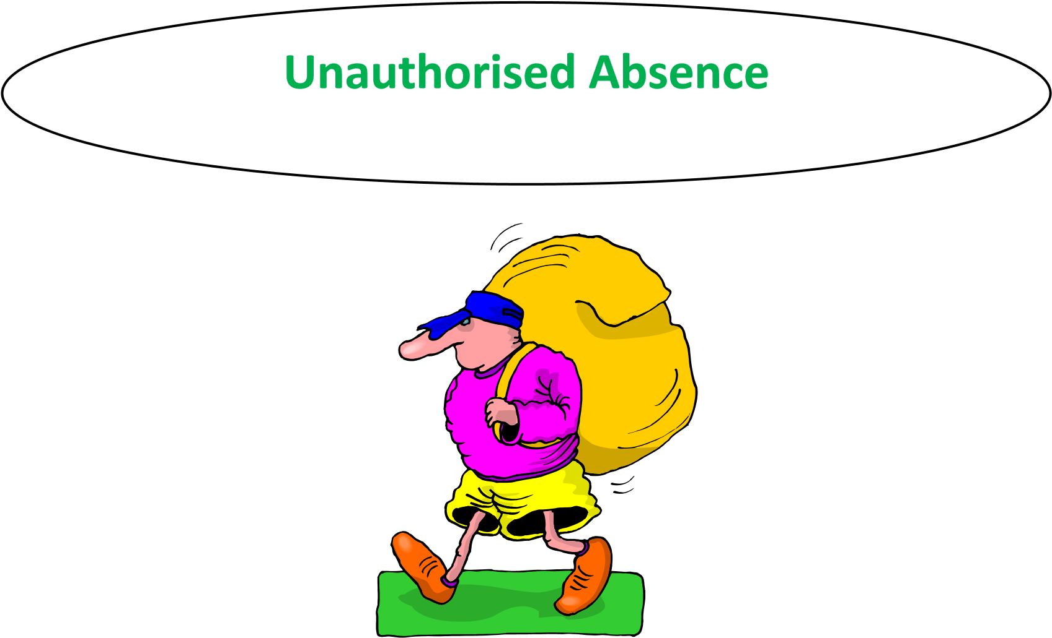

If you fail to return, or run away, from New Hall Barn the following will happen:

The Police, you’re Social Worker and/or the Emergency Duty Team (social work night-time team) will be informed immediately as will your family, if appropriate.

When you return, a discussion will take place as to why you felt the need to run away, and we will try to help and support you with anything that is troubling you. We will also involve an outside agency to give you a chance to talk about anything that may be troubling you.

If you do run away, wherever you are, don’t feel frightened about contacting us, you will not be told off, and we just want to know that you are safe. We will always discuss things with you, to try to make sure that you are happy and safe.



**Complaints Procedure**

If you have a problem or feel you are not being fairly treated:

First talk to the person you feel is causing the problem

**OR** talk to someone caring for you in your staff team **OR** go and see the manager.

**OR** Contact your Social Worker, Parent, or a member of your family.

**OR** contact your Advocate.

**OR** our independent visitor Lee Webster

If none of this works, try the following:

**Option 1:**

Make a formal complaint by writing down what you are worried about then give the written complaint to Veronica Dodd–Registered Manager she will tell you what she is doing about your complaint.

# If this doesn’t work: -

**Option 2:**

Inform your Social Worker and / or Independent Reviewing Officer

**Option 3:**

The National Youth Advocacy Service (NYAS) is information, advice, support, and advocacy service for young people. It is independent, confidential, and free. They will help you if you need it. The telephone number is:

0808 808 1001 (free).

**(Weekdays 9.00am – 7.00pm and Saturdays 9.00am – 1.00pm. messages can be left at all other times.)**

NYAS is CONFIDENTIAL and INDEPENDENT. They do not work for New Hall Barn, and they will give you all the advice and support that you will need.

# If this doesn’t work: -

**Option 4:**

You can also contact OFSTED who inspects your home on a regular basis. Their address and telephone number are: **0300 123 1231**

**I Hooper Ofsted (Inspector)**

Piccadilly Gate

Store Street Manchester

M1 2WD

**Option 5:**

Children’s Commissioner – Rachel de Souza

Her team spends lots of time listening to what children and young people who live away from home say about how they are looked after.

Free phone:

020 7783 8330

Or write to her at:

Children's Commissioner for England

Sanctuary Buildings

20 Great Smith Street

London

SW1P 3BT

Staff at New Hall Barn will do their up most to help you if you wish to make a complaint. We hope that your complaint is dealt with quickly.

**Suggestions**

If you have any suggestions as to how the information in this booklet could be improved or how things at New Hall Barn could be better, please tell your manager or your staff team. You can also raise them in the Young Persons weekly meetings.

**Remember, we are always happy to listen.**



**Childline 0800 1111**

**Coram Voice for children 0808 800 5792**

**Kidscape 020 7730 3300**

**Children’s Society 0300 303 7000**

**supportacare@chidrenssociety.**

**org.uk**

**Get connected 0808 808 4994**

**NSPCC helpline 0800 11111 or text 888858**